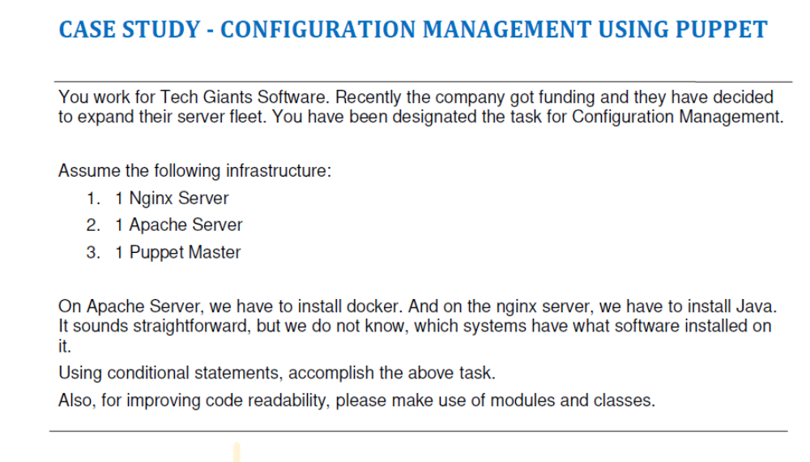
On the Puppet-Master
ubuntu@ip-172-31-33-191:~$ clear
ubuntu@ip-172-31-33-191:~$ cd /etc/puppet/code/environments/production/manifests
ubuntu@ip-172-31-33-191:/etc/puppet/code/environments/production/manifests$ ls
site.pp
ubuntu@ip-172-31-33-191:/etc/puppet/code/environments/production/manifests$ sudo nano site.pp
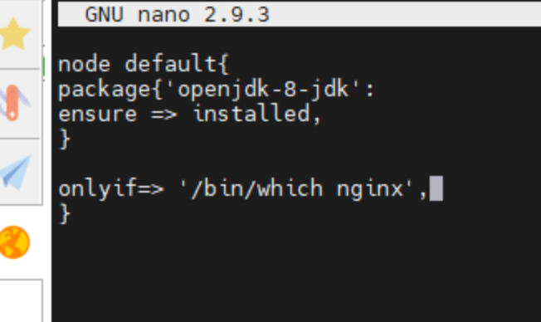
ubuntu@ip-172-31-33-191:/etc/puppet/code/environments/production/manifests$ sudo systemctl restart puppet-master

On Slave-1
ubuntu@ip-172-31-47-7:~$ sudo systemctl status nginx
● nginx.service - A high performance web server and a reverse proxy server
Loaded: loaded (/lib/systemd/system/nginx.service; enabled; vendor preset: enabled)
Active: active (running) since Wed 2021-12-08 22:27:46 UTC; 30min ago
Docs: man:nginx(8)
Process: 866 ExecStart=/usr/sbin/nginx -g daemon on; master_process on; (code=exited, status=0/SUCCESS)
Process: 811 ExecStartPre=/usr/sbin/nginx -t -q -g daemon on; master_process on; (code=exited, status=0/SUCCESS)
Main PID: 870 (nginx)
Tasks: 2 (limit: 1140)
CGroup: /system.slice/nginx.service
├─870 nginx: master process /usr/sbin/nginx -g daemon on; master_process on;
└─872 nginx: worker process
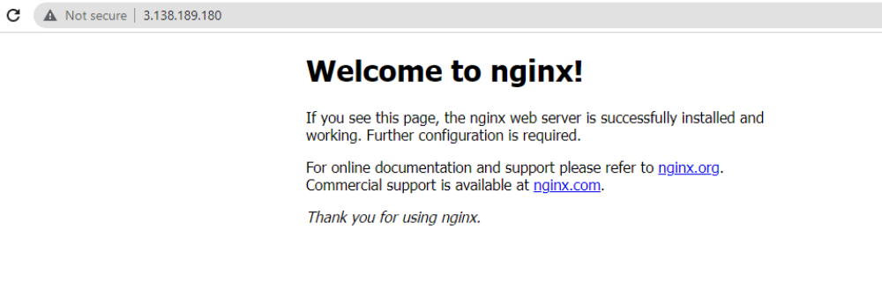

Dec 08 22:27:45 ip-172-31-47-7 systemd[1]: Starting A high performance web server and a reverse proxy server...
Dec 08 22:27:46 ip-172-31-47-7 systemd[1]: nginx.service: Failed to parse PID from file /run/nginx.pid: Invalid argument
Dec 08 22:27:46 ip-172-31-47-7 systemd[1]: Started A high performance web server and a reverse proxy server.
ubuntu@ ip-172-31-47-7:~$ sudo puppet agent --test
Info: Using configured environment 'production'
Info: Retrieving pluginfacts
Info: Retrieving plugin
Info: Retrieving locales
Info: Loading facts
Info: Caching catalog for ip-172-31-47-7.us-east-2.compute.internal
Info: Applying configuration version '1638926995'
Notice: /Stage[main]/Main/Node[default]/Package[nginx]/ensure: created
Notice: /Stage[main]/Main/Node[default]/File[/tmp/status.txt]/ensure: defined content as '{md5}33953125d5378c23cb0a98b5e2efe1d0'
Notice: Applied catalog in 5.59 seconds
ubuntu@ ip-172-31-47-7:~$ cd /tmp
ubuntu@ ip-172-31-47-7:/tmp$ ls
status.txt
systemd-private-a1bd90b62f9f4c058b727197ad0ef8e4-systemd-resolved.service-H3cZjb
systemd-private-a1bd90b62f9f4c058b727197ad0ef8e4-systemd-timesyncd.service-z6jU9b

ubuntu@ip-172-31-47-7:~$ java -version
openjdk version "1.8.0_292"
OpenJDK Runtime Environment (build 1.8.0_292-8u292-b10-0ubuntu1~18.04-b10)

